

Sedgwick County Animal Lease Agreement
Sedgwick County 4-H recommends a lease agreement be completed by the 4-H family and kept as a personal record for the 4-H project. This is a lease agreement. 4-H members/family and animal owner may choose to use this form when entering a lease agreement.

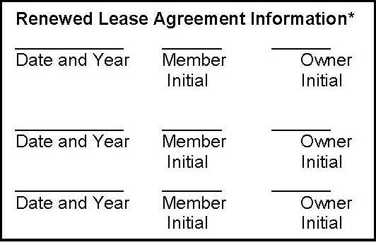

4-H Members Name: ____________________________________

Animal Owner’s Name: ________________________________
Animal Owner’s Farm Name (if applicable): _________________
Address where leased animals are housed:
_____________________________________________________
_____________________________________________________

Animal Information
Animal’s Name | Species & Breed | Animal Birthdate  month/day/year | Official Ear Tag or Tattoo (NA for Horse, Llama - Alpaca & Dog) | Registration Number  (If Registered) (NA for Horse, Llama - Alpaca & Dog)
* Some animals may be a lease pr Some animals may be a lease project in subsequent years (breeding beef, cow/calf pair, dairy, dog, dairy goat, horse, llama - alpaca, breeding poultry, breeding rabbit and breeding sheep).

Responsibilities:
Responsibilities for the leased animal will be distributed as follows.
- Describe 4-H member(s) and owner’s responsibilities for the care of the leased animal.
_________________________________________________________________________________________________________________________________________________________________________________________________________________________________________________________________________________________________________________________________________________________________________________________
- Describe 4-H off FFA member/family responsibilities for expenses.
________________________________________________________________________________________________________________________________________________________________________________________________________________________________________________________________________________________________________________________________________________________________________________________

Agreements

Term of the Agreement:
The term of this contract shall be on or before March 15 through the Sedgwick County event for this animal. This contract may be terminated at any time by mutual agreement in writing, or by at least 10 day(s) written notice from either party. Note: Dairy animals leases will start earlier to meet the “prior to first freshening rule”, if the animal meets criteria for rule.

Additionally, the 4-H or FFA member (Lessee) agrees to:
- Contribute to the care, training, feeding, and management of the leased animals as outlined above.
- Allow the owner to breed the animal in the direction and the expense of the owner, if applicable. The resulting offspring shall be the property of the owner who shall take possession of the animal at weaning or end of the lease agreement.
- Follow the project requirements as outlined in the Sedgwick County 4-H Fair book
- Review the Information Sheet (Rulebooks for dog and horse) for this species and will abide by all project rules and guidelines.

Additionally, the owner of the animal (Lessor) agrees to:
- Allow the 4-H/FFA member/family to use the above listed animals as a project from the date of the lease through the Sedgwick County event for this animal.
- Provide opportunities for the 4-H/FFA member(s) to participate in hands-on learning about the care, training, feeding and management practices for the leased animal and to contribute to the care and expense as outlined above.
- Refrain from allowing any other individual (including the owner) to enter/exhibit the animal in any show/exhibition during the time this agreement is in effect. (This includes junior shows, open shows, jackpot shows, etc.) Violation of this rule will make the animal ineligible for full-privilege exhibition in 4-H county or state shows. (See animal science lease information sheet for exceptions.)
- Allow the lessee to keep any premiums or awards earned while exhibiting the animal during the duration of this agreement.
- Review the Information Sheet (Rulebooks for dogs) for this species and will abide by all project rules and guidelines.

Owner’s Signature_________________________________________________ Date______________
Member’s Signature________________________________________________ Date______________
Parent/Guardian’s Signature_________________________________________ Date______________

