4-H Meetings Using Zoom
Thank you, 4-H families and volunteers for your motivation and willingness to try something new and different as we temporarily move our 4-H meetings to a digital format. We recommend using a laptop/Chromebook/tablet since it has a larger screen, but your cell phone will work as well. To feel connected as a 4-H club we recommend that 4-H’ers utilize a device with a camera and headphones, if possible, to reduce background noise.
Laptop/Chromebook
- Click on the link sent to you by your leader and allow the application to open.
Example: Join Zoom Meeting
https://ksu.zoom.us/j/xxxxxxxxxx
Meeting ID: xxx xxx xxxx
- Follow the prompt and provide your full name.
- Click “Join with Computer Audio.” If that doesn’t work, you can try calling in using a phone.
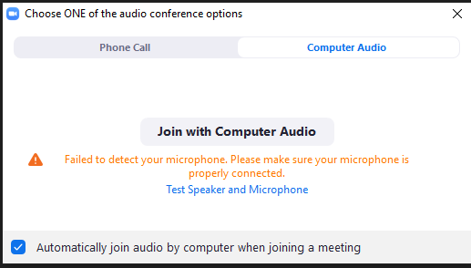
If you are having trouble joining with Computer Audio, you might need to call in using a cell phone.
Try “joining with Computer Audio” first.

Tablet, Smartphone, or iPad:
- Click on the link sent to you by your leader and allow the software to open.
Example: Join Zoom Meeting
https://ksu.zoom.us/j/xxxxxxxxxx
Meeting ID: xxx xxx xxxx
- Download and install the “Zoom for Cloud Meetings” software.
- Open the application and click “Join a Meeting”
or
Click “Join”
Click “Join a Meeting”
- Join the meeting by filling out the meeting ID and name.
Enter the meeting ID provided by your leader and enter your full name.
We recommend unchecking both these boxes.
Click “Join” after adding all the details.

Tips and Tricks:
We recommend keeping participants muted and having one person serve as a leader who organizes the group, especially for larger groups. The leader should encourage specific individuals to speak, so you are not speaking over one another.
Click here at the end of the meeting to close the application.
Keep chat professional and respectful.
We highly recommend using video if you can.
Remember to mute your microphone unless you are speaking to the group.

More Questions? Access the Zoom Help Center: https://support.zoom.us/hc/en-us

Kansas State University Agricultural Experiment Station and Cooperative Extension Service
K-State Research and Extension is an equal opportunity provider and employer.

