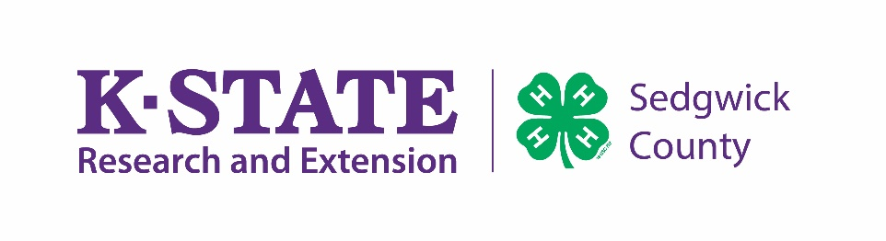
Sedgwick County 4-H County Fair Grievance Policy
K-State Research and Extension is committed to providing equal opportunity for participation in all programs, services and activities. Accommodations for persons with disabilities may be requested by contacting the Extension office at 316.660.0100. Requests received will be honored when it is feasible to do so.

Purpose: Differences in opinions are a part of life. To ensure consistency and fairness, a written grievance process is necessary to respond to and resolve 4-H issues and complaints in a manner that teaches good character, life skills, and positive youth development. The 4-H grievance process allows for members to raise their concerns.
Grievance: an official statement of a complaint over something believed to be wrong or unfair. What may be grieved?
- Alleged wrongdoing.
- Rule violations.
- Qualifications or eligibility of competing person, animal or object submitted in 4-H classes or events at the Sedgwick County Fair.

What may not be grieved?
- Decisions made by judges, which are final.
- Issues related to deadlines for membership enrollment, livestock identification, and or county fair pre–registration; extension staff will provide due process.
- Code of conduct – related violations that will be addressed by staff.

Who may grieve an issue?
- Sedgwick County 4-H member and their parent/guardian.

Who responds to the grievance?
- 4-H staff members will forward grievances to the Extension Director who may utilize the grievance committee consisting of the Sedgwick County 4-H Youth Development Program Committee members, Extended PDC, Extension Executive Board, or State Officials if conflict of interests arise.
Extension staff will notify the individual(s) filing the grievance of the decisions. Extension staff have ex-officio status with the grievance committee.

- The extension agent, together with the local extension board or governing district body, has the authority to make appropriate decisions on local 4-H disputes that do not fall under grievance policy procedures. These decisions will be formulated using state policy and national directives as formulated by this policy or as dictated by law.

- District and state 4-H staff may provide resources to the situation when asked by the extension agent.

Grievance Procedure
  - All grievances must be submitted to 4-H Staff using the official grievance form AND signed by the petitioner.

  - A $20 deposit will accompany the written grievance, which will be forfeited if the petitioner does not attend the grievance resolution meeting. The deposit will be returned upon completion of the process. If the deposit is forfeited, it will be applied to the 4-H program budget within the Sedgwick County Extension Council for 4-H programming purposes. Committee decisions are final.

  - Grievances must be submitted within 24 hours following the incident being protested. The grievance will be acknowledged after receiving the written grievance and will be responded to in a timely manner.

Grievance Committee
The grievance committee consisting of the Sedgwick County 4-H Youth Development Program Committee members will review the written grievance. Extended PDC may be utilized if conflict of interests a rise. If the grievance committee determines that the nature of the protest is not 4-H related, the protester will have the option of taking their protest to the Sedgwick County Fair Board.

  - The committee may call for a face-to-face or virtual meeting with affected petitioners and event leadership to discuss the situation and the official ruling. Recommendations will be developed, followed, and communicated both verbally and in writing to the petitioner or group affected.

  - Failure of the petitioner to attend this meeting with the Grievance Committee will result in no action and forfeiture of the deposit.

  - In cases of grievances, the 4-H youth/parent/leader may continue to participate. Results of participation will be subject to change based on the outcome of the grievance process. The Grievance Committee and Event Leadership reserves the right to withhold any award.

Sedgwick County 4-H County Fair Grievance Form

For Extension office use only
Received by:

Received on:
Printed name of Extension staff member receiving form

at
Grievance hearing date and time: Form submitted by: |  |  | date time  at
 |  |  | date time
Payment received: |  | Printed name(s) of 4-H member(s) filing grievance  (county level: $20, county staff fill in amount and initial)

Date of grievance:

Names of persons involved:

Grievance (complaint or appeal):

Action or rule in question:

Additional persons the committee may contact for further clarification:

Procedures and/or steps carried out by the person involved prior to submission of the petitioner to the grievance committee:

Outcome desired (petitioner recommendation for correction):

Printed names and signatures of those filing the grievance
Name Signature

Date signed: Contact information:

A $20 deposit will accompany the written grievance, which will be forfeited if the petitioner does not attend the grievance resolution meeting. The deposit will be returned upon completion of the process. If the deposit is forfeited, it will be applied to the 4-H program budget within the Sedgwick County Extension Council for 4-H programming purposes. Committee decisions are final.

COMMITTEE USE ONLY
DATE:_
COMMITTEE
DECISION:_

