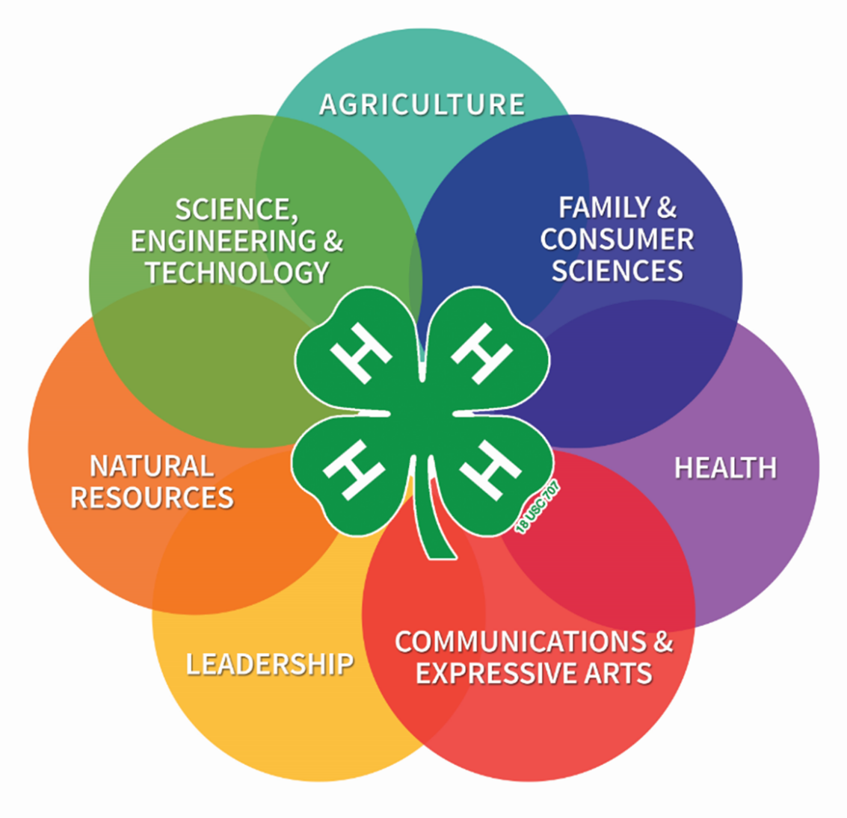

Our Sedgwick County 4-H curriculum library is packed with engaging, research-based project resources designed to make leading a 4-H project easier and more impactful. These materials provide ready-to-use lesson plans, hands-on activities, discussion guides, and project ideas that help bring 4-H projects to life. Checking out curriculum allows you to confidently teach new skills, spark youth curiosity, and enhance learning without having to start from scratch.

Leader-Friendly Checkout Statement
By checking out these 4-H curriculum materials, I acknowledge that they are the property of the Sedgwick County 4-H Program and agree to use them for 4-H educational purposes. I understand that I am responsible for returning all materials in good condition by the designated return date.

For curriculum available for checkout please follow this link: W:\group\4-H\Web Site - New\4-H Curriculum updated Dec. 2025.xlsx

