LIVESTOCK SKILLATHON
Quality Assurance Exercise #2– Reading a Medication Label

Directions: Look at the following medication label and complete the questions that follow.

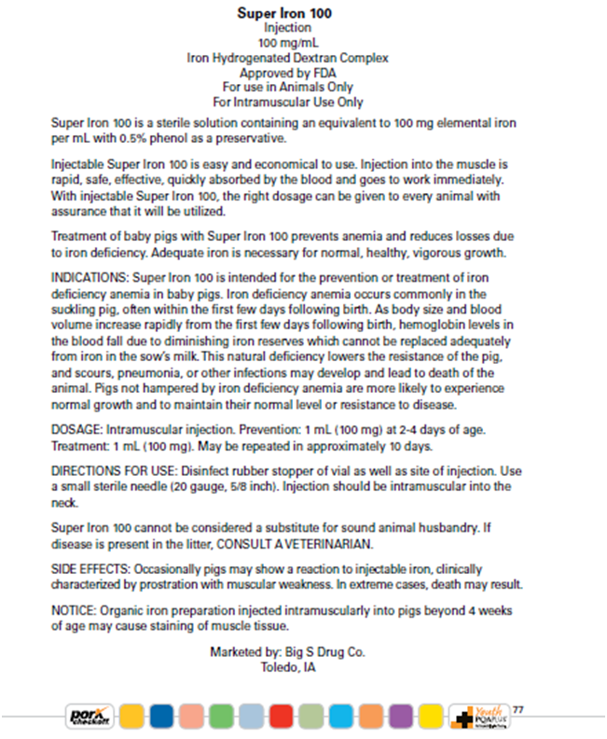

LIVESTOCK SKILLATHON
Quality Assurance Exercise #2– Reading a Medication Label

1. What is the name of the medication?

2. Name the active ingredient(s)

3. What specie(s) may this product be used on?

4. What condition is this approved to treat?

5. What is the dosage for a 200 lb. animal?

6. How long may this medication be used for treatment?

7. What is the route of administration?
a. subcutaneous injection b. intramuscular injection c. oral
8. How many milligrams of active ingredient can be found in 1 ml of solution?

9. What is the withdrawal time for this medication?

LIVESTOCK SKILLATHON
Quality Assurance Exercise #2– Reading a Medication Label

1. What is the name of the medication?
Super Iron 100
2. Name the active ingredient(s)
Elemental iron
3. What specie(s) may this product be used on?
Swine
4. What condition is this approved to treat?
Iron deficiency anemia
5. What is the dosage for animal?
1 ml
6. How long may this medication be used for treatment?
Repeated in 10 days
7. What is the route of administration?
a. subcutaneous injection b. intramuscular injection c. oral
8. How many milligrams of active ingredient can be found in 1 ml of solution?
100 mg
9. What is the withdrawal time for this medication?
None indicated

